### More Queries On Bank Database

**1. Retrieve all branches and their respective total assets**

Query : select branch_name, assets

from BRANCH_081;

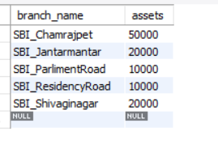

**2. List all customers who live in a particular city**

Query : select customer_name, customer_city

from BANK_CUSTOMER_081;

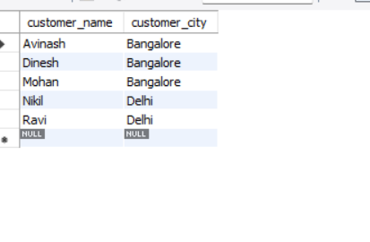

**3. List all customers with their account numbers**

Query : select customer_name, acc_no

from DEPOSITOR_081;

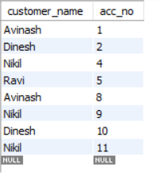

**4. Get the number of accounts held at each branch**

Query : select branch_name, count(acc_no) as total_accounts

from BANK_ACCOUNT_081

GROUP BY branch_name;

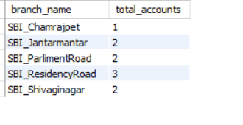

**5. Retrieve the branch with the smallest total loan amount**

Query : select branch_name

from LOAN_081

where amount=(select min(amount) from LOAN_081);

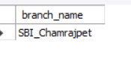

**6. Find all branches that have no loans issued**

Query : select branch_name

from BRANCH_081

where branch_name not in(select branch_name from LOAN_081);

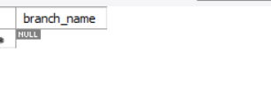

**7.Find all customers who have accounts with a balance greater than a specified amount (100000)**

Query : select d.customer_name

from DEPOSITOR_081 d, BANK_ACCOUNT_081 b

where d.acc_no=b.acc_no and b.balance>5000;

